Cloud Computing

**Name:** Jerusha Angel K

**Register No**: 727721EUCS049

Day-5

**Day 5_Autoscaling_CE1**

**Content Description:**

Create a launch template with a custom AMI and t2.micro instance type

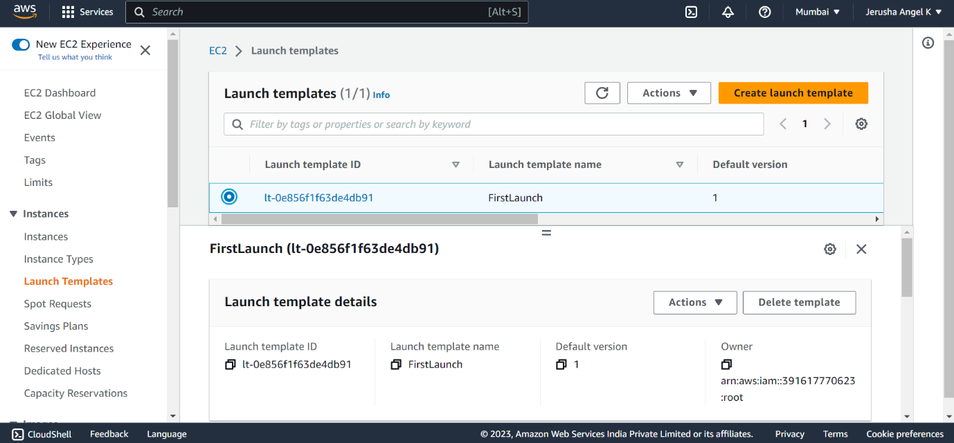

**Day 5_Autoscaling_CE2**

**Content Description:**

Create an autoscaling group with the above-created launch template

